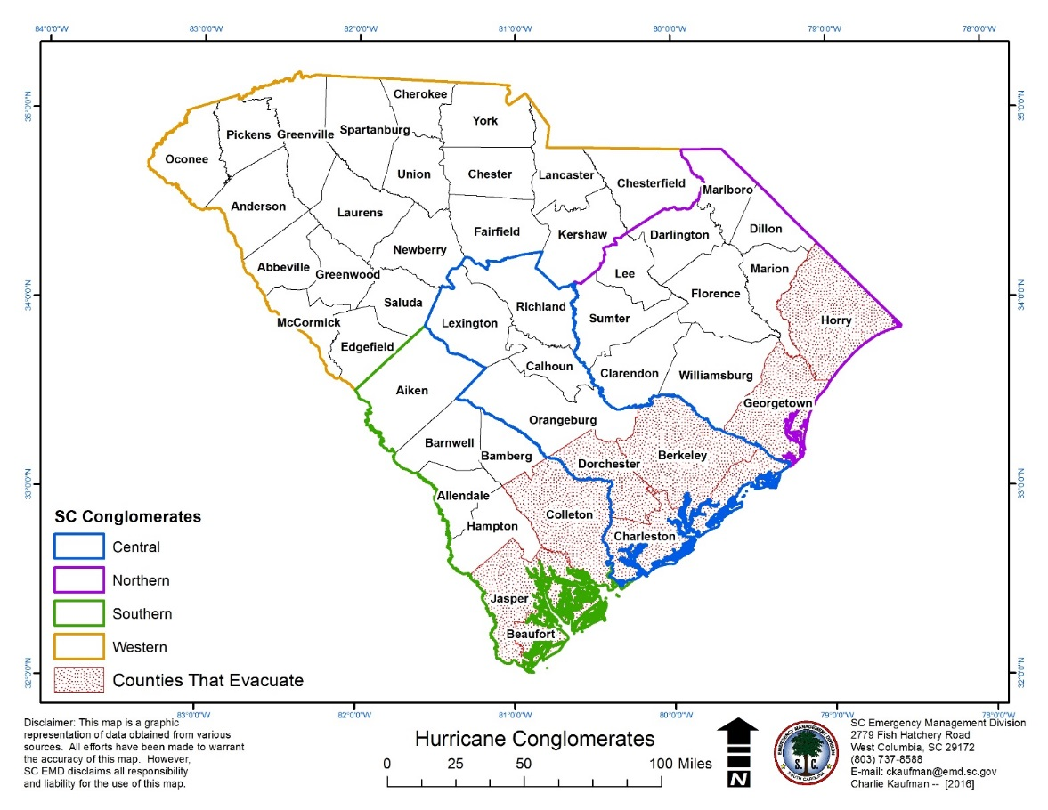H:\HUR-PLAN\MISC\congmap-2001.wmf